Day – 1: 16th May – 113195064 – Bondili Bhavya Charitha

**TASK: 1 What is SDLC?**

SDLC (Software Development Life Cycle) is like a recipe for building software as it goes through steps like planning, coding, testing, and maintaining to make sure it's well-made and works smoothly. It helps the teams to avoid messy errors and build efficient programs.

**TASK:2 – Why is SDLC?**

SDLC exists to keep software development error-free by following a structured process. It ensures teams plan, build, test, and improve software efficiently, avoiding chaos. Without SDLC, making software would be like building a house without a blueprint.

**TASK:3 – What are the stages of SDLC?**

The stages of SDLC are as follows:

* Planning – Deciding what the software should do and setting a game plan and Gathering requirements so we don’t miss any important details.
* Design – Sketching out the blueprint for how the system will work.
* Development – Writing the actual code and bringing ideas to life.
* Testing – Finding and fixing bugs before users get their hands on it.
* Deployment – Launching the software for people to use.
* Maintenance – Keeping it updated and running smoothly over time based on feedback.

**TASK:4&5&6 – SDLC Models, applications, advantages and disadvantages**

Models of SDLC are as follows:

* Waterfall Model – A step-by-step approach; once a stage is done, no going back, like a flowing waterfall. Ex: uses in government projects, banking systems.
* Advantages – Simple to understand and structured stages.
* Disadvantages – Once the project starts, you can’t change that.
* V-Model – Testing happens alongside development, like building and checking a bridge at the same time. Ex: uses in medical software’s and Defense applications.
* Advantages – With this, defects are identified early because of quality.
* Disadvantages – Expensive if changes required.
* Agile Model – Fast and flexible, with constant updates, like rolling out app updates every few weeks. Ex: uses mobile apps, E-commerce platforms.
* Advantages – Flexible to change as of continuous feedback.
* Disadvantages – Documentation could be less.
* Spiral Model – A mix of planning, testing, and repeating, perfect for high-risk projects. Ex: uses in Cybersecurity and financial systems.
* Advantages – Suitable for high-risk projects.
* Disadvantages – Expensive and very time consuming.
* Iterative Model – Build a rough version first, improve it step by step, like drafting and refining an essay. Ex: uses in Game deployment.
* Advantages – It is easy to test and debug in iterations
* Disadvantages – It needs more planning.
* Big Bang Model – No structured plan, just dive in and build, works best for tiny experimental projects. Ex: uses in small startups, academic research (PhD Research).
* Advantages – Required less planning as it is useful for small projects or experiments.
* Disadvantages – Not suitable for large projects.

**TASK:7 – What is scrum in agile?**

Scrum is like a team huddle in Agile as it helps developers work in short, focused bursts (sprints) to quickly improve software. It is a framework which is used to manage and execute complex projects.

**TASK:8 – What is sprint?**

A sprint is like a short race in Agile where a team works on specific tasks for 1-4 weeks to complete a goal. At the end, they review progress, adjust, and start the next sprint to improve things. It keeps projects fast and flexible.

**TASK: 9 - What are the dos and don’ts of Sprint?**

**Dos of Sprint:**

* Everyone should know what needs to be done in the sprint (clear goals).
* Daily communication needed.
* If something isn’t working, tweak it fast and resolve that.

**Don’ts of Sprint:**

* Review the results and improve in the next sprint.
* Skipping the communication results in the confusion.
* Quality is important not the speed.

**TASK:10 – What are the stories and backlogs in scrum world?**

* Stories: A story is a simple task that describes what needs to be built, like "As a user, I want a login button so I can access my account." It helps developers to understand the feature from a user’s perspective.
* Backlogs: A backlog is a to-do list for the project, filled with stories and tasks that need to be completed. The team pulls items from the backlog into each sprint to tackle them step by step.

**TASK:11 – Artifacts**

* Product Backlog: A big to-do list with all features, fixes, and ideas for the project, like a Wishlist for the product's future.
* Sprint Backlog: A short-term to-do list pulled from the product backlog, like the tasks that the team will complete in the current sprint.
* Burn-Down Chart: A progress tracker showing how much work is left in a sprint, like if the line drops fast, things are on track
* Increment: The finished work after a sprint, like each increment is a step closer to a complete.

**TASK:12 – What are Ports and Protocols?**

* Ports: Think of ports like doors on a computer, each one is a unique entry point used for different types of communication, like email, web browsing, or file transfers.
* Protocols: Protocols are like communication rules, ensuring devices understand each other, just like language rules help people have a smooth conversation.

**TASK:13 – What are the different network types?**

* LAN (Local Area Network) - A small network that connects devices within a limited area, like your home, office, or school WiFi.
* WAN (Wide Area Network) - A larger network that spans cities or countries—think the internet connecting people globally.
* MAN (Metropolitan Area Network) - Covers a city or town, like public WiFi hotspots or a university network.
* PAN (Personal Area Network) - A super-small network for personal use, like Bluetooth between your phone and smartwatch.
* VPN (Virtual Private Network) - A secure tunnel that hides your online activity and encrypts your connection.
* WLAN (Wireless Local Area Network) - A WiFi-based LAN without physical cables, like using WiFi at a café.
* SAN (Storage Area Network) - A special network for storing and accessing large amounts of data quickly.

**TASK:14 – What are the types of servers?**

* Web Server - Hosts websites so users can access them through browsers, like the powerhouse behind Google and Facebook.
* Database Server - Stores and manages data, making sure apps can retrieve, update, and save information efficiently.
* File Server - Acts like a shared drive, letting users store and access files over a network.
* Mail Server - Handles emails, sending, receiving, and storing messages for services like Gmail or Outlook.
* Application Server - Runs software applications and processes requests, like powering apps used by businesses and websites.
* DNS Server -Translates web addresses (like google.com) into IP addresses so computers can find sites.
* Proxy Server - Acts as a middleman for browsing, improving security and speed by filtering requests.
* Cloud Server - Runs apps and stores data remotely, allowing access from anywhere—used by platforms like AWS, Azure, and Google Cloud.

**TASK:15 - What do you know about DNS? Domain Name System**

DNS (Domain Name System) is like the internet’s phonebook as it translates website names (like google.com) into IP addresses so computers can find them. It helps load webpages quickly and ensures users reach the right site. Basically, it makes the internet way more user-friendly.

**TASK:16 - What are the different Network Topologies? Name the types, write 2 lines min about each with a diagram.**

Bus Topology - All devices are connected to a single backbone cable, like passengers sharing one bus route, if the cable breaks, everyone’s stuck.

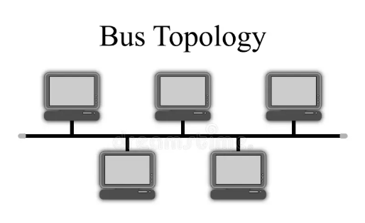

Star Topology - All devices link to a central hub, like a coffee shop where friends gather, if the shop closes, no more hangouts.

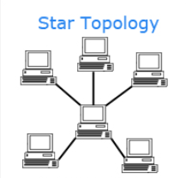

Ring Topology - Data travels in a loop, like passing a secret note in a circle, if one person drops out, the note gets lost.

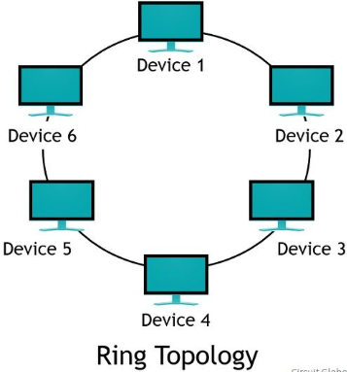

Mesh Topology - Every device connects to multiple others, like a group chat where everyone talks to everyone, super reliable.

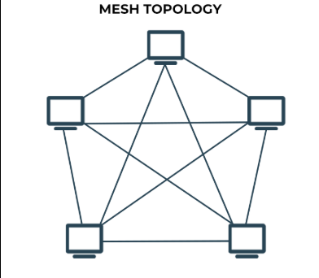

Tree Topology - Like a family tree, with branches connecting to bigger nodes, great for organizing large networks.

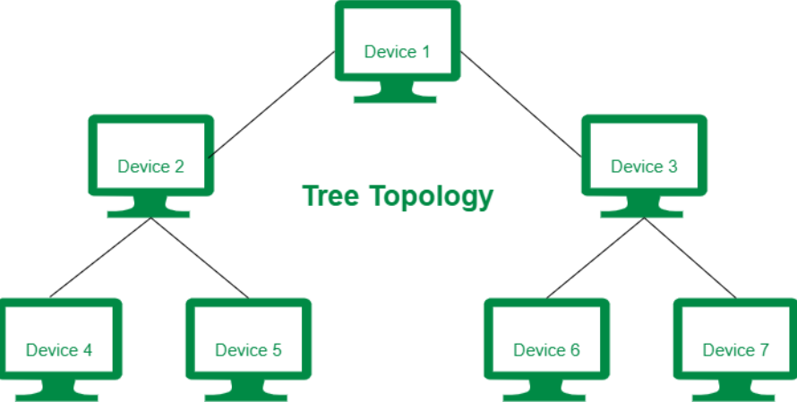

Hybrid Topology - A mix of different topologies, like a buffet with multiple cuisines, you get the best of everything.

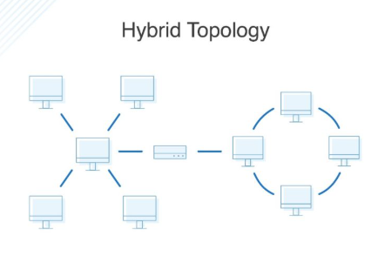

**TASK:17 - What is OSI Model? Describe the 7 layers with description.**

OSI (Open Systems Interconnection) model is a framework which helps to understand the interaction among different networking protocols in 7 distinct layers. Each layer has a specific function and are inter connected. Bottom – Top approach:

* Physical Layer – The hardware level, like cables, WiFi signals, and everything that moves data physically.
* Data Link Layer – Ensures error-free transmission and assigns MAC addresses, like a traffic cop directing the cars.
* Network Layer – Manages IP addresses and decides the best route for data, just like a GPS.
* Transport Layer – Ensures reliable data delivery using TCP/UDP, like a courier service.
* Session Layer – Starts, manages, and ends communication between devices, like a phone call organizer.
* Presentation Layer – Encrypts, compresses, and translates data formats so systems understand each other.
* Application Layer – The final stop, where emails, browsers, and apps interact with users.